**PYTHON**

* It was developed by Gudio van Rossum in 1991.
* It is high level language.
* It is easy for code readability.
* It is open source.
* It is interpreter language.
* It has lot of build in functions.
* It has lot of libraries for data handling.
* It has some data types (int, float, string, Boolean, list, tuple, etc)

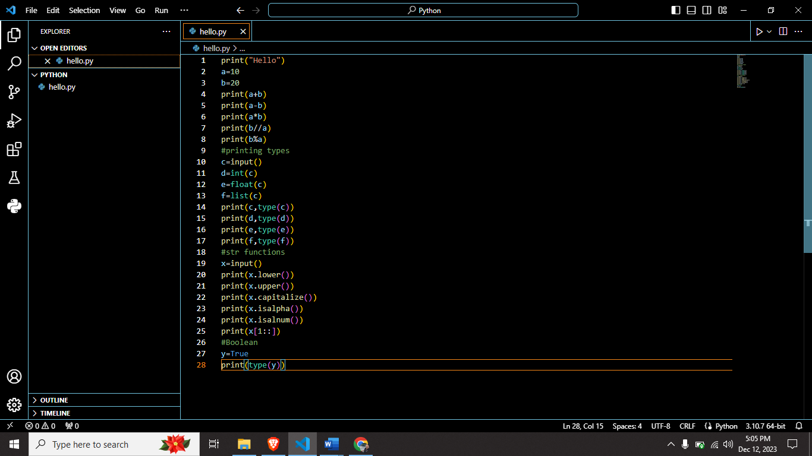

I write some basic programs in Python.

Printing function, Input function, type function, string functions and Boolean data types are used.

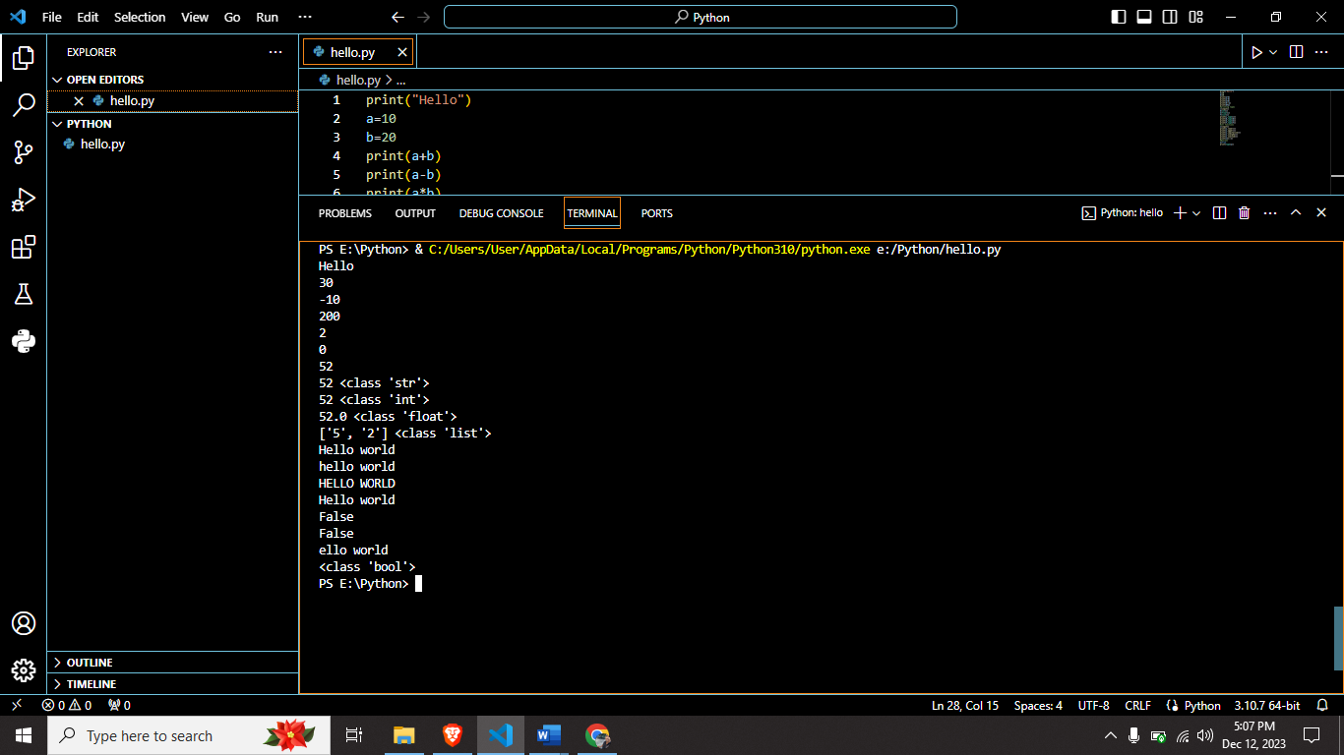

This is output of the Python code.